Stack Memory Organization

What is Stack Memory Organization
# Source: AI Source: Provided by: [Data Path: Persons Table -> ID Column: 1, Name_En Column: Motasem Essam] -> From: [Chatgpt (GPT‑5 Mini)] on [12/10/2025]
The Stack Memory Organization is a special area of memory that stores temporary data used by a program while it’s running. It’s called a stack because it works like a stack of plates: last in, first out (LIFO).

Key Features of the Stack
# Source: AI Source: Provided by: [Data Path: Persons Table -> ID Column: 1, Name_En Column: Motasem Essam] -> From: [Chatgpt (GPT‑5 Mini)] on [12/10/2025]
- Stores temporary variables
  - Local variables inside functions.
  - Function parameters.
  - Return addresses for function calls.
- Automatic memory management
  - Memory is allocated when a function is called and freed when the function returns.
  - No manual memory management needed.
- Fast access
  - Stack memory is very fast because it’s organized sequentially and the CPU knows exactly where the top is.
- Limited size
  - Stack memory is smaller than heap memory.
  - Too many nested function calls can cause a stack overflow.

Example of Stack Usage
# Source: AI Source: Provided by: [Data Path: Persons Table -> ID Column: 1, Name_En Column: Motasem Essam] -> From: [Chatgpt (GPT‑5 Mini)] on [12/10/2025]
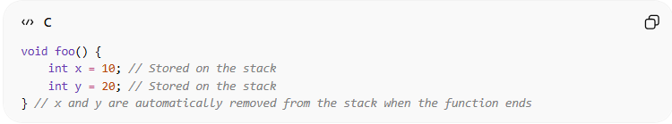
void foo() {
int x = 10; // Stored on the stack
int y = 20; // Stored on the stack
} // x and y are automatically removed from the stack when the function ends
- When foo() is called:
  - x and y are pushed onto the stack.
- When foo() finishes:
  - x and y are popped off the stack automatically.

Visual Representation
# Source: AI Source: Provided by: [Data Path: Persons Table -> ID Column: 1, Name_En Column: Motasem Essam] -> From: [Chatgpt (GPT‑5 Mini)] on [12/10/2025]
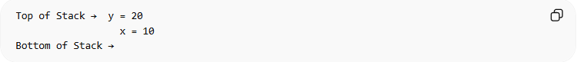
Top of Stack → y = 20
x = 10
Bottom of Stack →
- The top of the stack changes as functions are called and returned.

In short
# Source: AI Source: Provided by: [Data Path: Persons Table -> ID Column: 1, Name_En Column: Motasem Essam] -> From: [Chatgpt (GPT‑5 Mini)] on [12/10/2025]
In short, the stack is for temporary, short-lived data that follows LIFO, is fast, and is automatically managed by the CPU.

